ILVES-KILPAILU

TEHTÄVÄKÄSKY

SARJA: _________________________

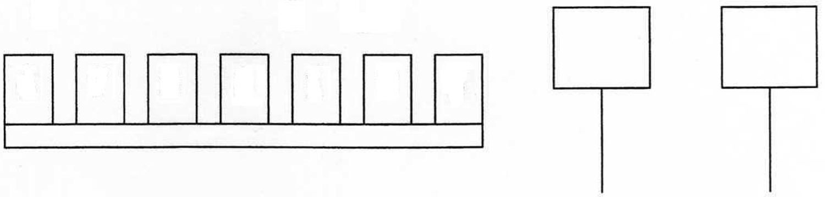

PIMEÄ TEHTÄVÄ:
_______________________________________________________________________________________

_______________________________________________________________________________________

_______________________________________________________________________________________

_______________________________________________________________________________________

_______________________________________________________________________________________

_______________________________________________________________________________________

_______________________________________________________________________________________

_______________________________________________________________________________________

_______________________________________________________________________________________

